30 minute Yoga Routine
This routine is intended for students who have attended ‘yogabeing’ classes and who are familiar with the poses.

If in any doubt about the suitability of any pose for you, please seek advice

Lay and relax for a few minutes, focusing on slowing down your breath  (You may wish to bend your knees) | 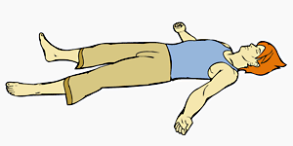
As you breathe in – extend arms back over head.  As you breathe out, slowly bend one knee in and hold around the shin, then take nose up to knee  Repeat x 3 alternating legs | 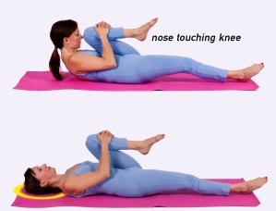
Pelvic tilts – laying, knees bent, arms by sides. Draw tummy down and then allow back to curve slightly coming into a very gentle lumbar arch | 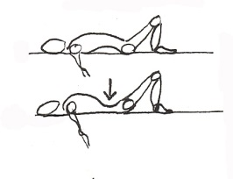
Moving on to Bridge pose  Repeat the tilts and allow spine to slowly lift off floor – vertebra by vertebra, and then placing gently down bit by bit.  Hold up in bridge pose for 6 breaths  Knees point straight up  Keep toes on the floor | 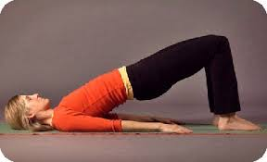
Hug knees into chest and rock gently from side to side

Knees bent, feet flat on floor, hip width apart
Arms out at shoulder height, palms up
As breathe out, let knees tip gently to left
Inhale to come up
As breathe out, let knees tip gently to right
Then hold knees down to each side for 4-5 breaths relaxing across shoulders
Have a good stretch!
Come to standing. Feet hip width, tummy in, shoulders back and down – Mountain pose – take a few breaths | 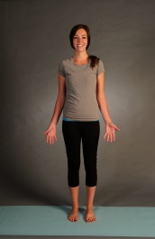
Breathe in as you take one arm up overhead and bend to opposite side as you breathe out  Repeat to other side  Repeat several times | 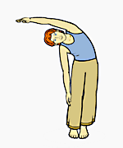
Tree pose. Balancing on one leg, take opposite foot to ankle/calf/thigh. Hands in Prayer pose. Stand tall.
Take hands above head. Open arms out to sides. Bring hands back to prayer pose.
Repeat standing on other foot.
Flat back forward bend.
Feet wide. As breath out, bend from hips keeping back long. Either rest forearms on thighs or take hands right down to floor. Keep knees soft.
Can hold toes/calves and extend back as breathe in, then fold down as breathe out
Hold for a few breaths.
Slowly roll up, head last as breathe out
Gentle back bend – hands to ‘jeans pockets’ open front body to gentle back bend – shoulders loose | 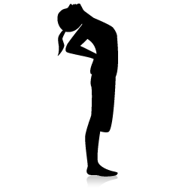
Cat pose. On all fours – table top.  Breathe out and arch spine  Breathe in and extend spine  Repeat several times | 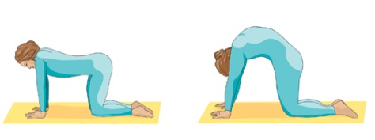
Childs pose  Relax into childs pose – can rest head in hands or take right down.  Try to sit bottom onto heels – or cushion  Breathe slowly – feeling breath in back | 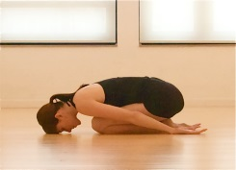
Savasana – relaxation
Enjoy!

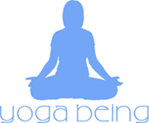 www.yogabeing.co.uk 07917 453224

