15 minute Floor based Yoga Routine
This routine is intended for students who have attended ‘yogabeing’ classes and who are familiar with the poses.

If in any doubt about the suitability of any pose for you, please seek advice

Lay and relax for a few minutes, focusing on slowing down your breath  (You may wish to bend your knees) | 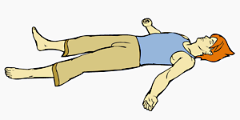
As you breathe in – extend arms back over head.  As you breathe out, slowly bend one knee in and hold around the shin, then take nose up to knee  Repeat x 3 alternating legs | 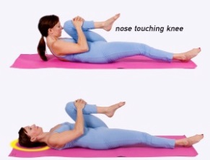
Pelvic tilts – laying, knees bent, arms by sides. Draw tummy down and then allow back to curve slightly coming into a very gentle lumbar arch | 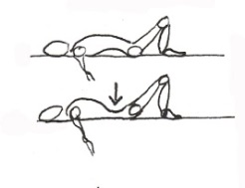
Moving on to Bridge pose  Repeat the tilts and allow spine to slowly lift off floor – vertebra by vertebra, and then placing gently down bit by bit.  Hold up in bridge pose for 6 breaths  Knees point straight up  Keep toes on the floor | 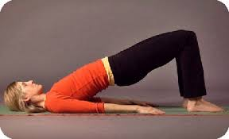
Hug knees into chest and rock gently from side to side

Laying Twist
Knees bent, feet flat on floor, hip width apart
Arms out at shoulder height, palms up
As breathe out, let knees tip gently to left
Inhale to come up
As breathe out, let knees tip gently to right
Then hold knees down to each side for 4-5 breaths relaxing across shoulders
Stretch out arms above head, legs straight out
Banana Stretch  Arms above head or clasped behind head  Move feet to right, then move upper body to right creating curved shape to body – hold for 5-6 breaths  Repeat to left  Stretch out arms above head, legs straight out | 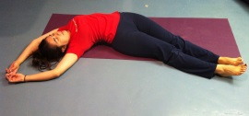
Savasana – relaxation – for a few minutes
Enjoy!

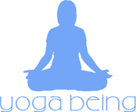 www.yogabeing.co.uk 07917 453224

